🛡️ NorthStar – Enterprise Insurance AI Agent
A Bedrock + RAG + Serverless Architecture on AWS

1️⃣ Executive Summary (Non-Technical View)
NorthStar is an AI-powered insurance assistant that can:
- Answer questions about insurance policies
- Check document requirements
- Retrieve claim status
- Search internal policy PDFs using AI (RAG)
- Maintain conversation memory
- Provide responses in a ChatGPT-style interface
It works by combining:
- 🤖 Amazon Bedrock (LLMs)
- 📄 OpenSearch Vector Search (RAG)
- ⚙️ AWS Lambda (Serverless backend)
- 💬 Streamlit UI (Chat interface)
- 🗄️ DynamoDB (Conversation memory)

2️⃣ High-Level Architecture
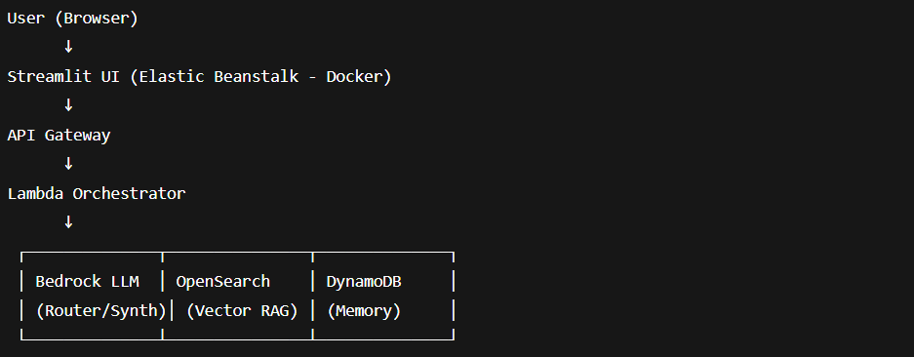
3️⃣ System Components Explained (Simple Terms)
Component | Purpose
Streamlit | Chat interface like ChatGPT
API Gateway | Secure entry point
Lambda Orchestrator | AI brain logic
Bedrock | Large Language Models
OpenSearch Serverless | Vector search for PDFs
DynamoDB | Stores chat history
S3 | Stores policy PDFs

4️⃣ Step-by-Step Implementation Guide

PHASE 1 — Infrastructure Setup

✅ Step 1: Create S3 Bucket
Used to store policy documents.
Upload PDFs such as:
- Fraud prevention guides
- Policy documents
- Compliance manuals

✅ Step 2: Create OpenSearch Serverless (Vector Collection)
- Create collection:
  - Type: Vector Search
  - Name: insurance-data
- Create Index (example mapping):
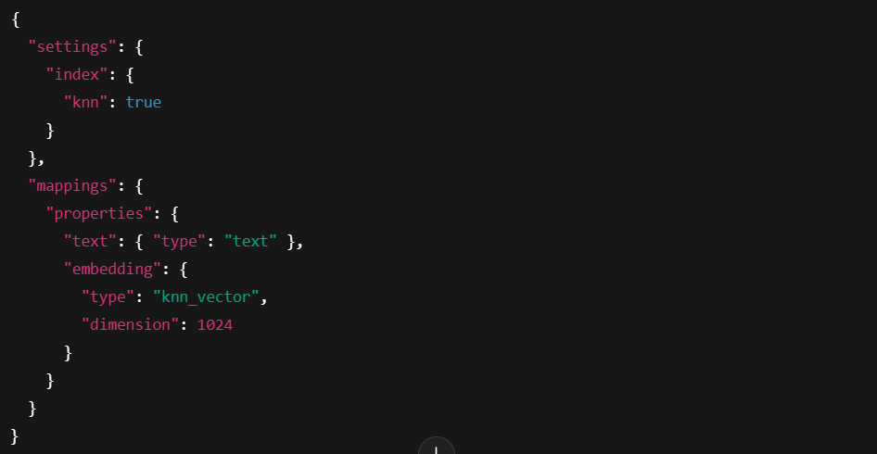
⚠️ Ensure dimension matches your embedding model.

✅ Step 3: Configure Data Access Policy
Allow Lambda role access:
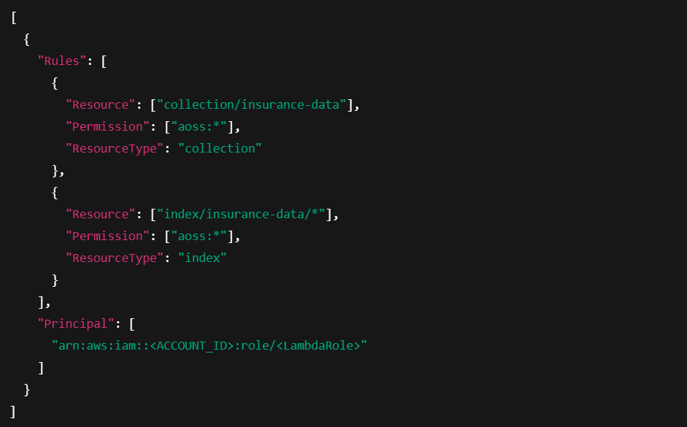
✅ Step 4: Create DynamoDB Table
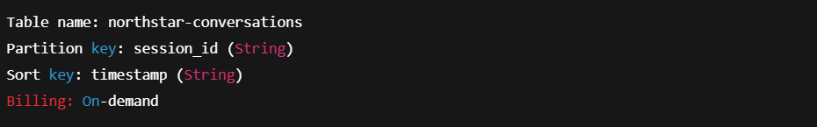
PHASE 2 — Backend AI (SAM + Lambda)

✅ Step 5: Build Lambda Functions
You created:
Function | Purpose
get_policy_details | Retrieves policy info
get_claim_status | Retrieves claim data
check_document_requirements | Document rules
agent-orchestrator | AI brain

✅ Step 6: RAG Indexing Lambda
Triggered when PDF uploaded to:
s3://insurance-s3bucket/documents/
Process:
- Extract PDF text
- Chunk text
- Generate embeddings (Titan)
- Index into OpenSearch

✅ Step 7: Agent Orchestrator Logic
The Orchestrator does:
- Receives question
- Routes to correct tool
- Retrieves memory (DynamoDB)
- Retrieves RAG context (OpenSearch)
- Synthesizes final answer (Bedrock)

✅ Step 8: Deploy Using SAM + GitHub
GitHub workflow:
Environment variables:
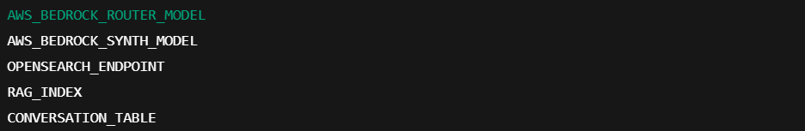
PHASE 3 — Frontend (Streamlit UI)

✅ Step 9: Build Streamlit Chat Interface
Features:
- Chat history
- New Chat button
- DynamoDB session list
- Typing animation
- Confidence badge
Environment variables:
AGENT_API
CONVERSATION_TABLE
AWS_REGION

PHASE 4 — Deployment (Elastic Beanstalk)

✅ Step 10: Containerize Streamlit
Dockerfile
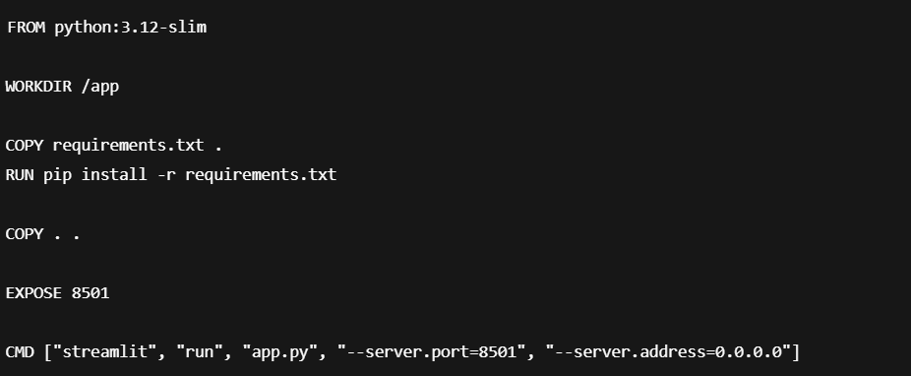
✅ Step 11: Deploy via GitHub → Elastic Beanstalk
Workflow:
- Push to GitHub
- GitHub Actions:
  - Build container
  - Deploy to EB
  - Set environment variables

PHASE 5 — Testing

Test Backend via Curl
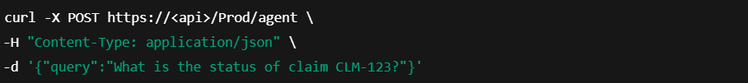
Test RAG
Upload PDF → Verify:
- CloudWatch logs show indexing
- Query retrieves relevant content

5️⃣ AI Flow (Detailed Technical Explanation)

Routing
LLM decides:
Tool Execution
Lambda invoked via:
lambda_client.invoke()

RAG Retrieval
knn query → OpenSearch
Returns top 3 chunks.

Synthesis
Final prompt includes:
- Tool output
- RAG chunks
- Conversation memory

6️⃣ Security Architecture
Layer | Security
API Gateway | HTTPS
Lambda | IAM Role
OpenSearch | IAM-based access
Bedrock | IAM policies
DynamoDB | IAM controlled
Elastic Beanstalk | Security group

7️⃣ Business Value
- Reduces call center workload
- Increases response consistency
- Improves compliance
- Enables document intelligence
- Maintains audit trail

8️⃣ Operational Considerations
Concern | Solution
Scaling | Lambda auto-scales
Cost | Serverless = pay per use
Logging | CloudWatch
Monitoring | AWS X-Ray optional
Model switching | Environment variables

9️⃣ Common Issues & Fixes
Issue | Fix
403 OpenSearch | Update Data Access Policy
Vector mismatch | Align embedding dimension
Model not supported | Use text model (Nova Lite)
Missing policy_id | Add extraction logic
No RAG results | Verify index name

🔟 What You Built
You built:
✅ Multi-tool AI Agent
✅ Enterprise RAG system
✅ Serverless architecture
✅ Conversation memory
✅ Production deployment
✅ CI/CD pipeline
✅ ChatGPT-like frontend

🎯 Final Architecture Summary
Layer | Technology
UI | Streamlit
Container | Docker
Hosting | Elastic Beanstalk
API | API Gateway
Compute | Lambda
AI | Bedrock
Vector DB | OpenSearch Serverless
Memory | DynamoDB
Storage | S3
CI/CD | GitHub Actions

🚀 What Makes This Enterprise-Grade?
- Tool-based architecture
- Guardrail prompt constraints
- RAG with vector search
- Session memory
- IAM secured
- CI/CD automation
- Containerized frontend
- Serverless backend

🏁 Conclusion
This project demonstrates a full modern AI system:
Agentic AI + Retrieval + Cloud-native architecture + Production UI
It is replicable, scalable, secure, and enterprise-ready.

